Cell Division: Meiosis
What is the definition of meiosis?
Meiosis is __________________________________________________________________
__________________________________________________________________________

What is the purpose of meiosis?

Where does meiosis occur?

What are the stages involved in meiosis?

Phase of Meiosis | Description of Phase | Images of Phase
Interphase  (before meiosis) | The cell functions as normal  The DNA is in the form of threadlike chromatin  The DNA duplicates itself | 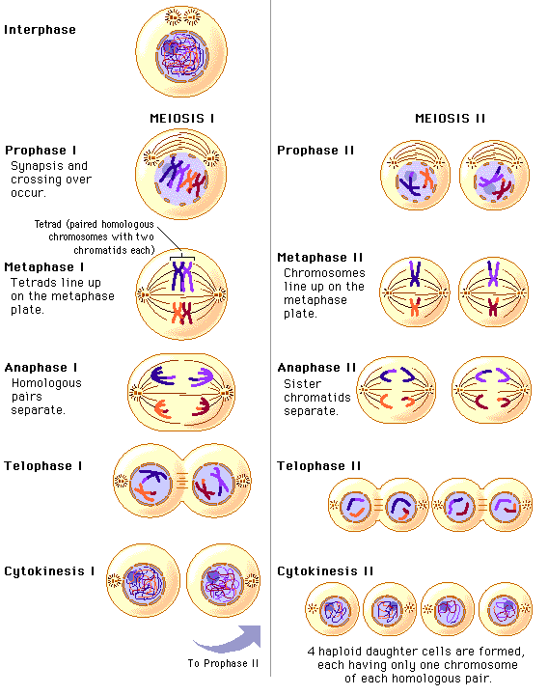
Prophase I | DNA condenses into visible chromosomes  Nuclear membrane breaks down and spindle forms  Homologous chromosomes pair up and crossing over occurs
Metaphase I | Paired chromosomes line up in the centre of the cell  Spindle fibre attaches to the centromeres
Anaphase I | The spindle fibres contract, pulling one of each pair of chromosome to opposite ends of the cell
Telophase I | New nuclear membranes start to form  Cell pinches in the middle and splits into two
Prophase II | Nuclear membrane breaks down  Spindle forms around the chromosomes
Metaphase II | Chromosomes line up in the centre of the cells  Spindle fibres attach to centromeres
Anaphase II | Chromatids separate and move to opposite poles of the cell
Telophase II | New nuclear membranes form  Cells divide into two  Four daughter cells are produced with half the number of chromosomes
Interphase  (after meiosis) | DNA unwinds into threadlike chromatin
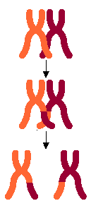
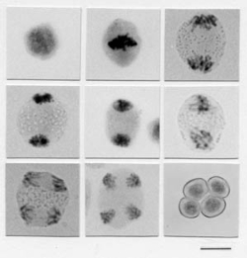
Crossing Over
This is a process that is unique to meiosis
Parts of adjacent chromosomes are able to cross over and exchange parts of their DNA
This creates four distinct chromatids



